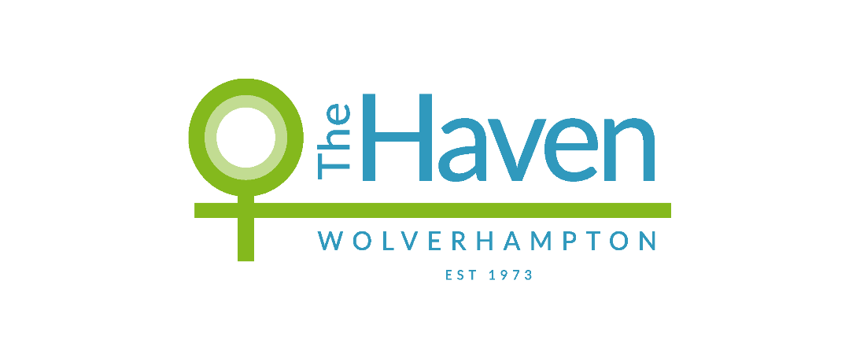
The Haven Wolverhampton

COMPLIMENTS, COMMENTS AND COMPLAINTS
POLICY & PROCEDURES

VERSION | DATE REVISED | REASON FOR REVISON | REVISED BY WHOM | DATE RATIFIED BY BOARD/SMT
1 | July 2019 | Annual review | SMT | July 2019
2 | July 2020 | Annual review | SMT | July 2020
3 | January 2022 | Annual review | SMT | Draft

Context

The organisational values of The Haven Wolverhampton (THW) are that we:
- Provide Safe, high quality support in an environment of dignity and respect
- Listen and respond with understanding and compassion
- Act with responsibility and diligence

Whilst we commit to provide a quality service for women and children, we also strive for excellence and to continually improve our service. We welcome and value feedback, which enables us to listen, learn and respond to the views of our service users, stakeholders and other agencies.

This policy is for individuals (service users / members of the public), stakeholders and other agencies. It does not apply for employees, agency workers, volunteers, board members or any third party contracted by our organisation. Any complaints from such persons are to be raised in line with employment policies and procedures, including Whistle Blowing Policy.

Compliments
We are keen to listen to feedback regarding what we are doing right and how this is making a difference. This will enable us to give feedback to staff and other key supporters and influence the continued development of our services.

Comments
Some feedback may not fall into the compliments or complaints categories, but may still be of equal value. Hearing from you about what you think about our organisation and its staff team will support us to maintain standards and influence decisions for development.

Please email any compliments or comments to fedback@havenrefuge.org.uk

Complaints
We recognise that we do not always get things right, and by responding positively to complaints, we have the opportunity to be restorative in our learning and address any concerns in a timely manner.

We aim to ensure that:
- making a complaint is as easy as possible
- we treat a complaint as a clear expression of dissatisfaction with our service which calls for an immediate response
- we deal with complaints promptly, politely and, when appropriate, confidentially
- we respond in the right way - for example, with an explanation, or an apology where we have got things wrong, or information on any action taken etc;
- we learn from complaints, use them to improve our service, and review annually our complaints policy and procedures.

To aid us with this, we have developed a 4 stage approach to complaints (see Appendix 1). This approach enables complaints to be managed appropriately at informal and/or formal stages.

Many concerns raised can be dealt with informally, at an early stage and resolutions can be found quickly. Often at this stage, contributors may wish to share concerns without seeking escalation or further action (excluding safeguarding concerns*). Mediation between the complainant and the individual to whom the complaint has been referred may be beneficial. This informal approach is appropriate and often preferred, where this can be achieved.

If concerns cannot be satisfactorily resolved informally, then the formal complaints procedure should be followed, using the complaint form (below).

If you feel that you have been treated unfairly or inappropriately while receiving The Haven services or you are unhappy about the service or facilities provided by us, you have the right to make a formal complaint. Any complaints will be taken seriously and properly investigated.

At The Haven, we understand that making a formal complaint can be a difficult decision to make, particularly if you are receiving services from us. We want to assure you that if you do make a complaint, we will strive to ensure that you will not be made to feel pressured, uncomfortable or treated less fairly because of it, by any member of our team. If at any point in the complaint procedure you feel that this has happened then you should contact a Senior Manager as soon as possible and this will be investigated immediately.

Feedback through universal and online platforms
Many service users and/or partners wish to leave feedback on universal platforms, such as Google Review, which enables the public to view their feedback. We encourage the use of these platforms for feedback, although we are unable to support complaints via these routes, without further communication.

Where possible, we will reach out to any persons that post online Google reviews, providing opportunities for further discussion. We particularly encourage service users to seek resolution through a complaints process. This provides service users with a formal channel to have their voice heard and for The Haven Wolverhampton to formally manage any matters/actions.
Where reviews indicate concerns with a safeguarding and/or criminal element, service users will be directed to contact a named member of staff to support further.

We urge individuals to use caution and consider safety when leaving feedback on any universal online platforms. Often there is a requirement to submit personal identifying details, leaving an online footprint which may be accessible to others.

Quality monitoring
In line with The Haven Wolverhampton values and the Charity Governance Code, we review all feedback at a senior management and governance level.
Feedback data is collated for Trustee board at quarterly reviews. Feedback and online reviews have ongoing senior management oversight, which enables timely response and contributes to a learning organisation.

*Safeguarding -
There may be times when The Haven is required to share information with other statutory agencies.
Children - All organisations and agencies that work with children share an obligation to safeguard and promote their welfare. For many organisations, this commitment is underpinned by specific statutory duties.
The Haven has a duty under Section 11 of the Children Act 2004 to share any safeguarding concerns with the Local Authority and promote the welfare of children.

Adults - The Haven has a responsibility to adult safeguarding as defined within The Care Act 2014. This may include anyone ‘Aged 18 years or over; Who may be in need of community care services by reason of mental or other disability, age or illness; and who is or may be unable to take care of him or herself, or unable to protect him or herself against significant harm or exploitation’

Complaints and Appeals Procedure (Appendix 1)

Stage | Community & accommodation service users | External stakeholders and agencies
Stage 1  Informal | Complaint to Allocated (Key) Worker / Senior (Key worker  - The first step would be to take your complaint to your allocated worker at The Haven Wolverhampton. (If your complaint is specifically in relation to your allocated worker, please go straight to stage 2). You may feel it is better to put your complaint in writing at this stage. Explain what your complaint is and how you think it should be put right.  - If it is something that cannot be dealt with immediately you will get a response within 5 working days. Even if there has not been time to deal with your complaint in full someone will get back to you to let you know what has been done so far.  - When the allocated worker has investigated your complaint she will explain to you in person where possible and in writing, what she has done about it within 5 working days. | N/A ~ All external complaints will automatically be escalated to Stage 3 (Formal)
Stage 2  Informal | Complaint to Service Lead/Manager  - If you are not happy with the way your complaint has been dealt with, you can request for your complaint to be looked into by the Service Lead/Manager.  - The Service Lead/Manager will acknowledge your complaint within 5 working days and will tell you what action she is going to take to look into it.  - When the Service Lead/Manager has investigated your complaint, she will put this in writing to explain what action has been taken about your complaint in writing within 14 working days.  - If it is not possible to investigate your complaint and give you an outcome within 14 working days, they will contact you and give you an update and revised time scales. This should only be in exceptional circumstances.  * If you are not happy with the way your complaint has been dealt with, you can request for your complaint to be looked into by the Senior Service Delivery Manager, which will then formalise the complaint.
Stage 3  Formal | Complaint to Senior Management Team  - Please put your complaint to the Senior Management Team, in writing (using the form attached if possible) and send either to the email address or office address:  feedback@havenrefuge.org.uk  Feedback – SMT  The Haven Wolverhampton  18 Waterloo Road  Wolverhampton  West Midlands  WV1 4BL  - Explain what your complaint is and how you think it should be put right. Please try to provide as much information as possible.  - The Senior Management Team will acknowledge your complaint within 5 working days and outline what immediate action will be taken to look into it.  - When a member of the Senior Management Team has investigated your complaint, they will put this in writing to explain what action has been taken about your complaint in writing within 14 working days.  - If it is not possible to investigate your complaint and give you an outcome within 14 working days, the Senior Management Team will contact you and give you an update and revised time scales. This should only be in exceptional circumstances.
Stage 4  Formal | Appeal to Chief Executive  - If you are not happy with the outcome of your complaint, you have the option of contacting the Chief Executive and appealing against the decision.  - You should make your appeal within 5 working days of receiving the outcome, either by forwarding your concerns in writing to her at the following address:  The Haven Wolverhampton  18 Waterloo Road  PO Box 105  Wolverhampton  WV1 4BL  or by telephoning her on 01902 904677 to make an appointment to see her.  - The Chief Executive will write to you within 5 working days to tell you that your complaint has been received and what is being done to investigate it.  - Once the investigation has been carried out (up to an additional 14 working days) the Chief Executive will inform you, in person where possible and in writing, of what action has been taken. The Chief Executive’s decision will be final.

Please Note:

- At every stage of the complaint procedure you have the right to be kept informed of what is being done about your complaint and how long it is likely to take.

- If your complaint is about a member of The Haven Staff you should make your complaint to the Manager of this member of staff.

- If your complaint is about a Senior Manager you should make your complaint to Chief Executive Officer.

- You have the right to have a friend or relative or other professional or advocate involved in your case with you at any stage of the procedure to help you put your case across. You have to provide us at least 5 working days in advance the details of this person (name, position and relationship to yourself).

- When supporting a survivor of domestic abuse, we will not be engaging in any dialogue with perpetrators or individuals regarding any cases or the details of our processes. This is to ensure we maintain safeguards to a high standards and act in the best interest of the service users, who are our priority.

Legal Framework & Guidance
This Policy takes into account relevant legal requirements, regulations and guidance, including:
Care Act 2014
Charities (Protection and social Investments) Act 2016
Children’s Act 1989 and 2004
Data Protection Act 2018
Equalities Act 2010
Women’s Aid: National Quality Standards 2020
Working Together to Safeguard Children 2018
General Data Protection Regulation (GDPR)

Complaint Form
Completing this form is optional. You do not have to fill in a form to raise a concern. You may prefer to talk to staff members directly. However, if you are asking for an appointment with a Manager, a written Statement should be made.

Name:
Address: |  |  | Safe to receive post?  If NO alternative arrangements:
Tel No: | Safe to call? | Mobile: |  |  | Safe to call?
Safe times to call: |  | Safe times to call:
Note: You do not have to complete personal details, but if you do they will be kept confidential (excluding safeguarding*). However if you wish to receive a formal response, to your complaint you have to provide your details.
Statement:
(include the nature of the complaint, relevant dates and steps which have already been taken to rectify this matter)
Signed: |  |  |  | Date:
Please forward to the appropriate named person at The Haven Wolverhampton, 18 Waterloo Road,
Wolverhampton, WV1 4BL
INTERNAL USE – please scan and ensure complaint is filed into pending complaints
Date received
Staff managing complaint
Target outcome date

